**TASK 1**

**EMPLOYEE**

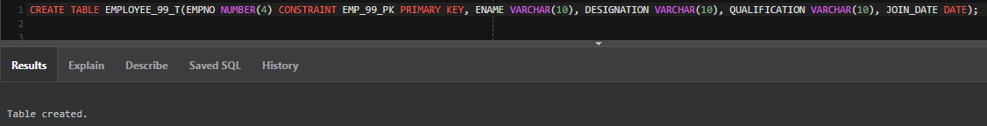

**PROJECT**

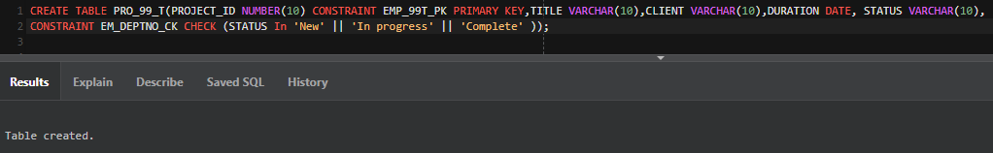

**EMP_PROJECT**

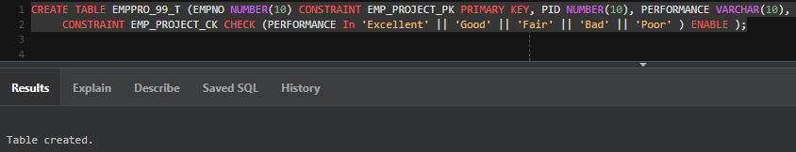

**GRADE**

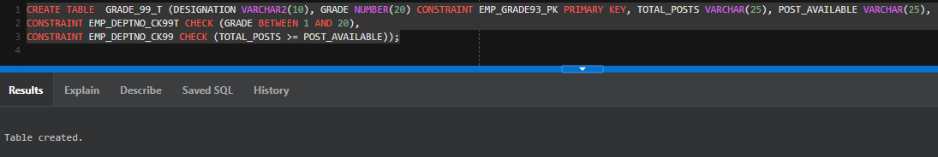

**EMP_TRAINING**

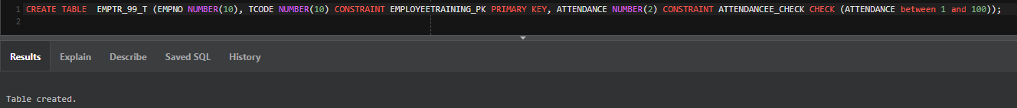

**TRAINING**

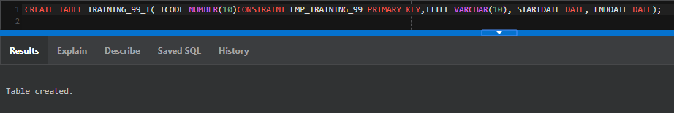

**TASK 2**

* *Gender* column to **EMP** table. The only possible values are *Male* and *Female*.

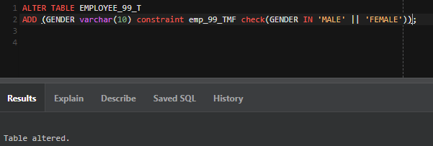

* *Instructor_Name* column to **TRAINING** table

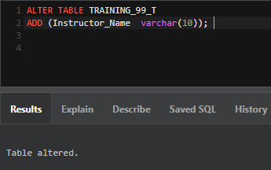

* *Salary* column to **GRADE** table

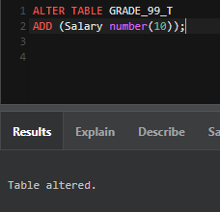

**TASK 3**

Q. What is database schema? What are the different objects included in it?

A database schema represents the logical configuration of all or part of a relational database. It can exist both as a visual representation and as a set of formulas known as integrity constraints that govern a database. These formulas are expressed in a data definition language, such as SQL. As part of a data dictionary, a database schema indicates how the entities that make up the database relate to one another, including tables, views, stored procedures, and more.